PENETRATION TESTING LAB REPORT

Stored Cross-Site Scripting (XSS)
PortSwigger Web Security Academy | Apprentice Lab

1. Executive Summary
A stored Cross-Site Scripting (XSS) vulnerability was demonstrated in the PortSwigger Web Security Academy lab, “Stored XSS into HTML context with nothing encoded.” The blog comment functionality accepted a JavaScript payload. After submission, the browser displayed an alert, and PortSwigger confirmed that the lab was solved.

2. Lab Information and Scope
Platform: PortSwigger Web Security Academy
Lab: Stored XSS into HTML context with nothing encoded
Vulnerability: Stored Cross-Site Scripting (XSS)
Difficulty: Apprentice
Injection point: Blog comment field
Scope: Assigned, intentionally vulnerable PortSwigger lab instance
Testing was restricted to the authorised training environment.

3. Vulnerability Overview
Stored XSS occurs when an application stores attacker-controlled input and later includes it in a page viewed by users without appropriate context-sensitive output handling. Unlike reflected XSS, the injected content is persisted by the application and can be served in subsequent page responses. In this lab, the comment functionality was the input point.

4. Methodology and Findings
- Opened the assigned lab and navigated to a blog post containing a comment form.
- Entered the test payload in the comment field: <script>alert(1)</script>.
- Submitted the comment using the application's comment form.
- Observed a browser alert displaying “1”, confirming that the injected JavaScript executed.
- Observed the successful comment-submission page and PortSwigger lab completion banner.

5. Proof of Concept
Injection point: Blog comment field
Payload: <script>alert(1)</script>
The payload was submitted as a blog comment. The resulting JavaScript alert is evidence of script execution. The completion banner confirms that the lab's success condition was met.

6. Security Impact
Stored XSS can affect users who later view the page containing the stored payload. Depending on the application, victim privileges and browser-side protections, impact may include page manipulation, phishing, access to information available to page scripts, or actions performed through an authenticated user's session. The lab evidence confirms JavaScript execution, but does not independently demonstrate each of these possible impacts.

7. Remediation
- Apply context-sensitive output encoding when displaying user-submitted comments.
- Use secure templating systems that encode untrusted values by default.
- If rich HTML comments are required, use a maintained allowlist-based HTML sanitiser.
- Avoid unsafe HTML insertion; prefer textContent for plain text.
- Use Content Security Policy (CSP) as defence in depth, not as a replacement for correct output handling.
- Add tests to ensure stored user input is rendered safely wherever it appears.

8. Evidence
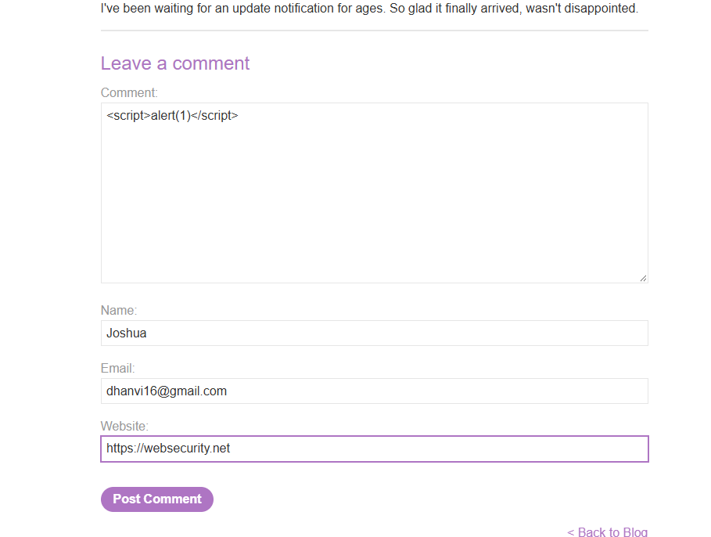
Figure 1. Test payload entered in the blog comment field.
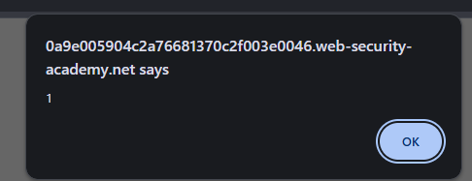
Figure 2. Browser alert displaying 1, confirming JavaScript execution.
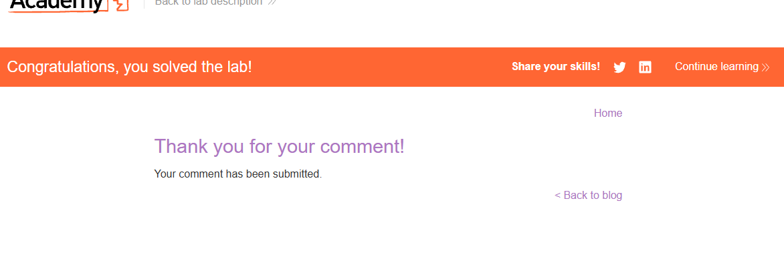
Figure 3. PortSwigger lab completion confirmation.

9. Conclusion
The lab demonstrated stored XSS through the blog comment functionality. The submitted payload executed in the browser, and the lab platform confirmed successful completion. The principal defensive measure is to ensure stored user input is safely encoded for the exact output context whenever it is rendered.

10. Limitations and Reporting Notes
This report documents a controlled training exercise, not a production-system assessment. The supplied screenshots show the payload in the comment field, the resulting alert and the lab completion page. They do not show a separate raw HTTP request/response capture or a later independent page visit triggering the stored payload; no such evidence is claimed here.
CVSS: Not assigned. A production severity score would require application-specific context and a justified impact assessment. CVE: None identified or applicable to this deliberately constructed lab.

